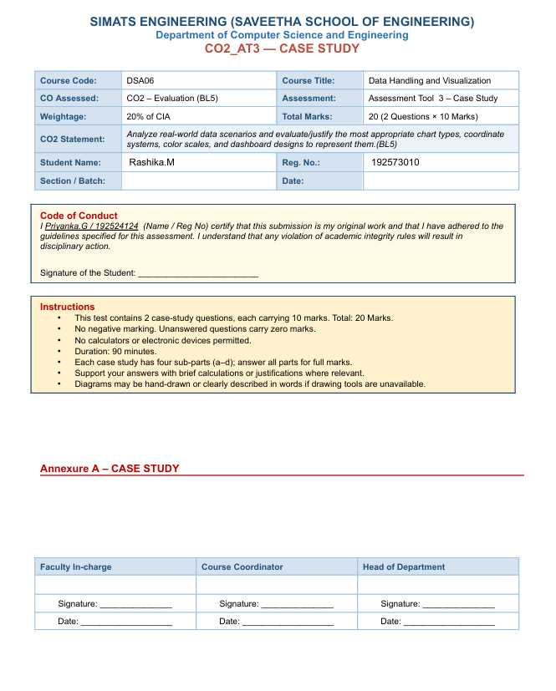

ASSESSMENT 3
Name: RASHIKA.M
Reg No: 192573010
Course Code: DSA-0606
Course Name: DATA HANDLING AND VISUALIZATION

Introduction
Data visualization plays a vital role in sports analytics by transforming raw team statistics into meaningful visual insights. Different chart types are suitable for different analytical purposes, such as comparing team performance, displaying win-loss composition, or analyzing player and team attributes. Selecting the appropriate visualization improves data interpretation, enables quicker decision-making, and highlights important performance trends. In this case study, various chart types are evaluated to identify the most effective methods for presenting team rankings, win-loss records, and attribute comparisons.
Objective
The primary objective of this analysis is to determine the most suitable visualization techniques for different aspects of team performance data. It aims to identify the best chart for displaying win-loss composition, select an effective coordinate system for comparing the top team's five attributes, and design a dashboard that combines team rankings with detailed attribute analysis. Additionally, the study evaluates how visualization techniques should be adapted when comparing the attribute profiles of all ten teams simultaneously, ensuring clarity, readability, and accurate data interpretation.

Team | Wins | Losses | Points | Attack | Defense | Speed | Stamina | Teamwork
Lions | 18 | 2 | 54 | 90 | 85 | 88 | 82 | 91
Tigers | 16 | 4 | 48 | 86 | 80 | 84 | 81 | 88
Eagles | 15 | 5 | 45 | 84 | 79 | 82 | 80 | 85
Sharks | 14 | 6 | 42 | 82 | 81 | 80 | 79 | 83
Bulls | 13 | 7 | 39 | 80 | 77 | 78 | 76 | 82
Wolves | 12 | 8 | 36 | 78 | 75 | 77 | 74 | 80
Hawks | 11 | 9 | 33 | 76 | 73 | 75 | 72 | 78
Panthers | 10 | 10 | 30 | 74 | 72 | 73 | 70 | 76
Falcons | 9 | 11 | 27 | 72 | 70 | 71 | 68 | 74
Dragons | 8 | 12 | 24 | 70 | 69 | 69 | 66 | 72

Question:
1(a) Which chart type shows win/loss composition per team most clearly?
Answer:
Use a Stacked Bar Chart because it clearly shows wins and losses together for each team. Tableau Steps: Connect the SportsTeam.xlsx data, drag Team to Rows, drag Wins and Losses to Measure Values, choose Stacked Bar Chart from Show Me, and color Wins green and Losses red.
Question:
1(b) Which chart type and coordinate system is best suited to comparing the top team's five attributes? Justify.
Answer:
Use a Radar Chart (Polar Coordinate System). If Radar Chart is unavailable in Tableau, use a Horizontal Bar Chart. Radar charts compare multiple attributes such as Attack, Defense, Speed, Stamina, and Teamwork at once.
Question:
1(c) Design a dashboard combining the teams' points ranking with the top team's attribute profile.
Answer:
Create one worksheet for team ranking using a horizontal bar chart and another worksheet for the top team's attribute chart. Open Dashboard, drag both sheets, add the title 'Sports Team Performance Dashboard' and include the narrative: 'The top team leads in points while maintaining balanced performance across all five attributes.'
Question:
1(d) If all 10 teams are compared, would the chart still work well?
Answer:
No. A radar chart becomes cluttered when many teams overlap. A Heat Map is a better alternative because it allows easy comparison of all teams across every attribute.

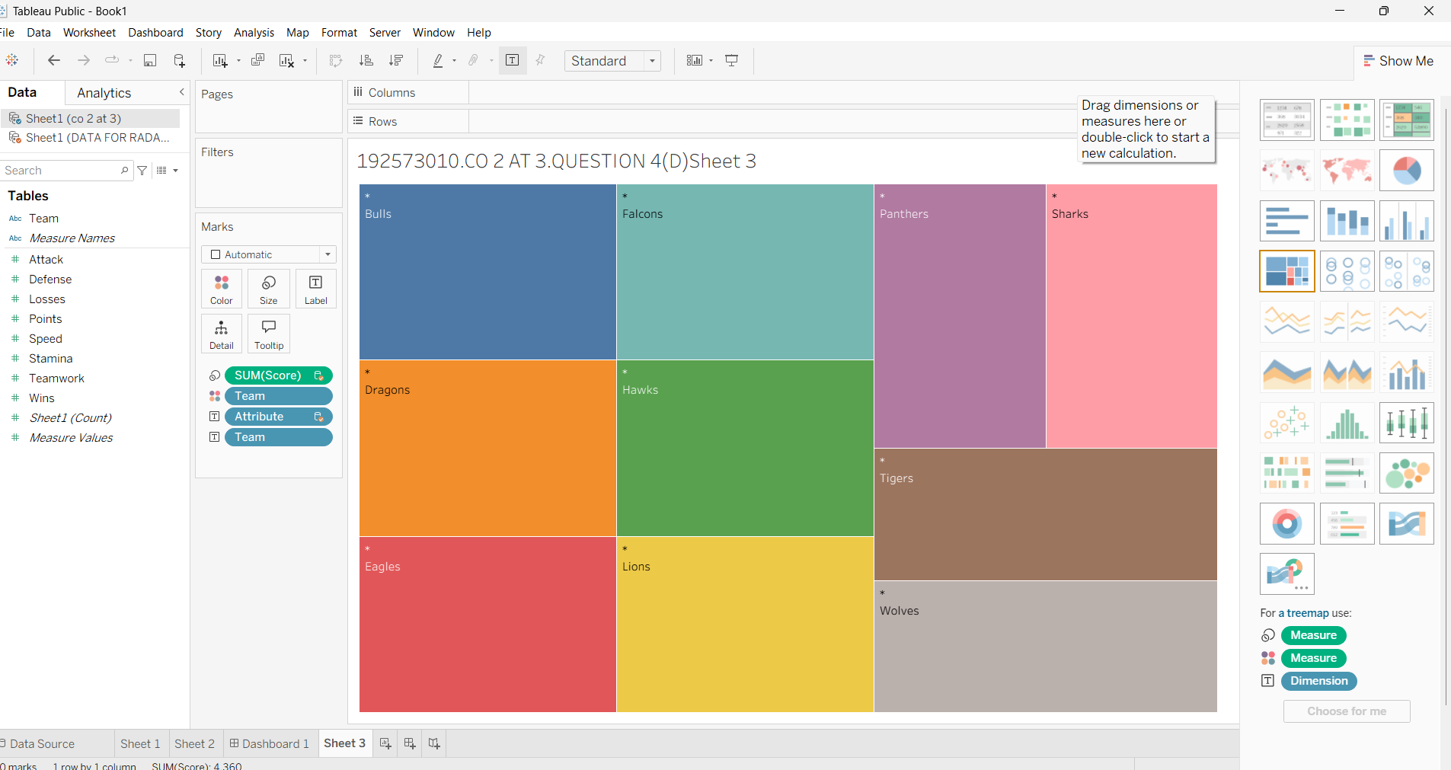
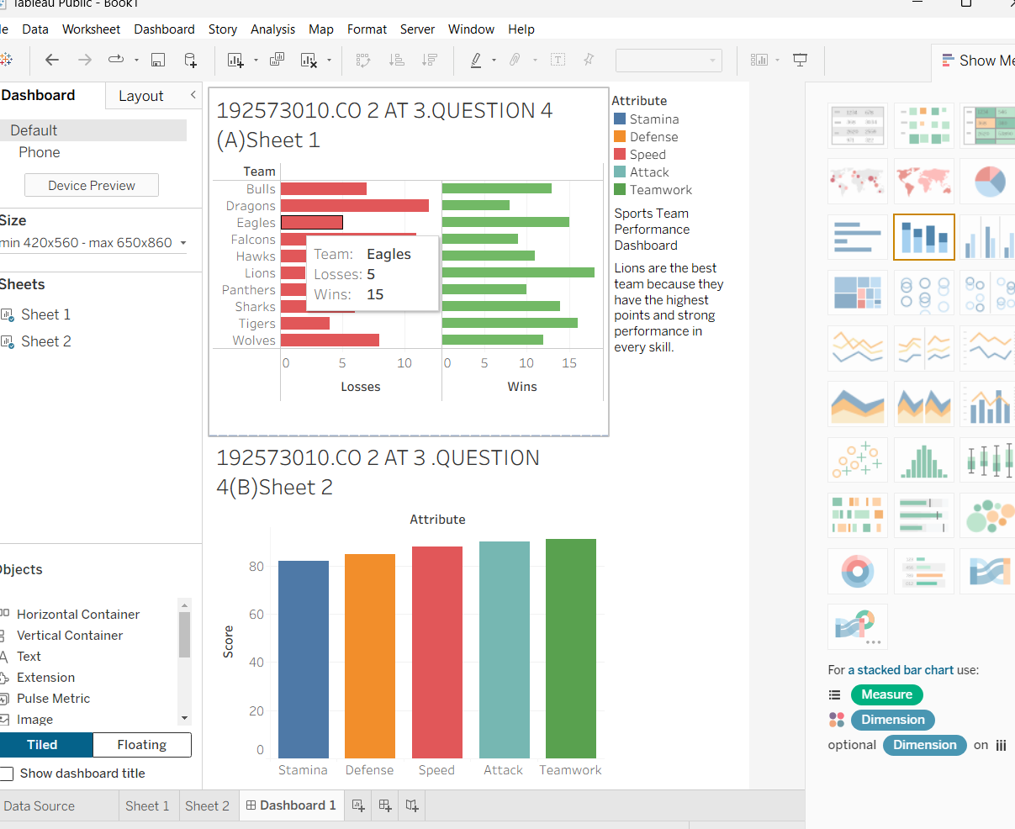

Conclusion
Choosing the correct chart type significantly improves the effectiveness of sports data visualization. Stacked bar charts clearly represent win-loss composition, while radar charts with a polar coordinate system effectively compare multiple attributes of a single team. A well-designed dashboard combining team rankings and attribute profiles provides a comprehensive overview that supports informed decision-making. However, when comparing all ten teams simultaneously, alternative visualizations such as parallel coordinates or heat maps are more appropriate than radar charts, as they reduce visual clutter and allow accurate comparison across multiple teams. Overall, selecting visualization methods based on the analysis objective leads to better understanding and communication of sports performance data.

2.QUESTION

Introduction
Manufacturing industries rely heavily on data visualization to monitor supplier performance, product quality, and production efficiency. Charts and graphs help identify defects, evaluate delivery performance, and analyze production trends over time. By selecting appropriate visualization techniques, manufacturers can quickly detect potential risks, recognize seasonal patterns, and make informed decisions to improve operational performance. This case study focuses on choosing suitable charts for supplier analysis and production monitoring.
Objective
The main objective of this case study is to identify the most effective visualization methods for analyzing supplier and production data. It aims to determine the appropriate axis scale for defect rate analysis, design a chart that combines shipment volume with on-time delivery performance, and recommend a suitable chart for displaying two years of production trends. The study also explores the use of a diverging color scale to visualize defect rate deviations from a target value, enabling easier identification of suppliers performing above or below the expected quality standard.

Question:
2(a) What axis scale is required for the defect rate data given its range, and why?
Answer:
Use a Linear Axis because defect rates vary within a small percentage range, making comparisons simple and accurate.
Question:
2(b) Design a chart combining supplier shipment volume and on-time delivery rate.
Answer:
Use a Dual Axis Chart. Drag Supplier to Columns, Shipment Volume to Rows, then drag On-Time Delivery beside Shipment Volume on Rows. Right-click the second axis and choose Dual Axis, then Synchronize Axis. Change the second Marks card to Line. This creates bars for shipment volume and a line for on-time delivery.
Question:
2(c) Propose a chart for the 2-year production volume trend.
Answer:
Use a Line Chart. Place Month on Columns and Production Volume on Rows. Color by Quarter or Month to highlight seasonal patterns.
Question:
2(d) Explain how a diverging color scale could be used.
Answer:
Create a Deviation field by subtracting the target defect rate from the actual defect rate. Apply a Red-Blue Diverging color palette where blue indicates below target, white indicates on target, and red indicates above target.
Supplier | Shipment Volume | On-Time Delivery (%) | Defect Rate (%) | Jan | Feb | Mar | Apr | May | Jun
S1 | 1000 | 98 | 1.5 | 950 | 970 | 980 | 990 | 1000 | 1020
S2 | 900 | 95 | 2.0 | 850 | 860 | 870 | 880 | 900 | 910
S3 | 850 | 92 | 3.5 | 800 | 810 | 830 | 840 | 850 | 860
S4 | 750 | 90 | 4.0 | 700 | 710 | 720 | 730 | 740 | 760
S5 | 650 | 88 | 5.5 | 620 | 630 | 640 | 650 | 660 | 670

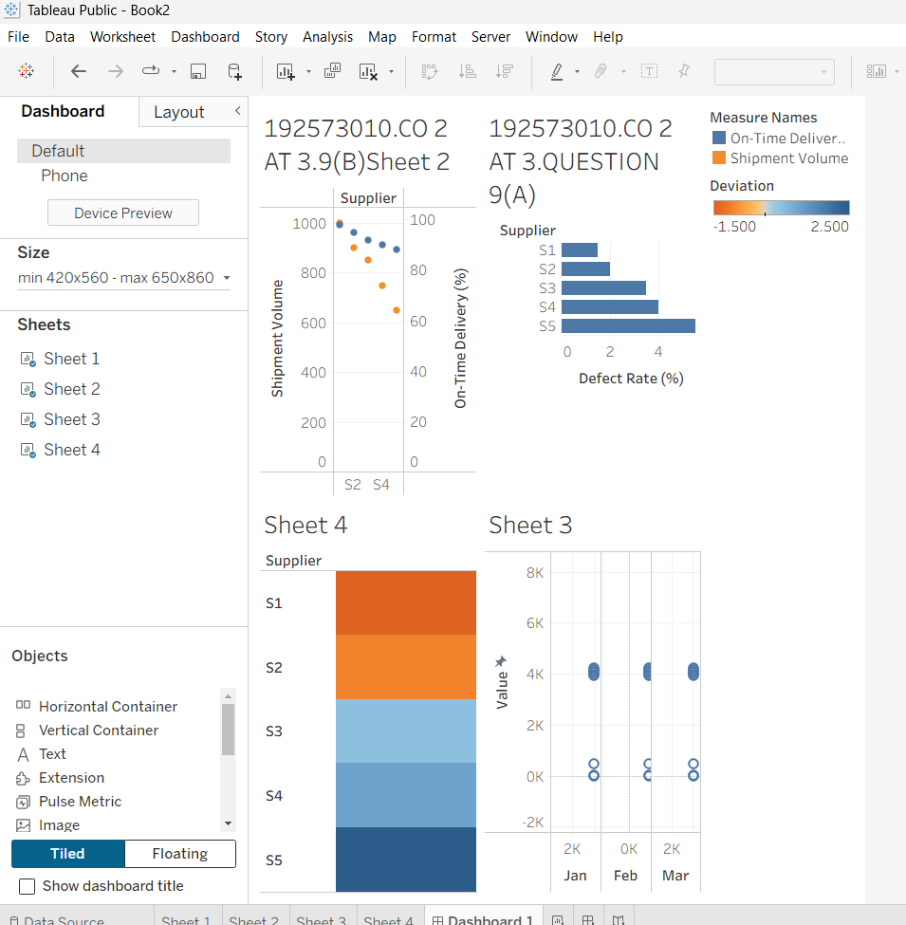
Conclusion
Selecting suitable visualization techniques improves the accuracy and clarity of manufacturing performance analysis. A properly scaled axis ensures defect rates are represented without distortion, while a combination chart effectively highlights suppliers with high shipment volumes and poor delivery performance. A line chart is ideal for illustrating two-year production trends and seasonal variations, making recurring patterns easy to identify. Furthermore, using a diverging color scale to represent deviations from the target defect rate allows decision-makers to distinguish between acceptable and problematic supplier performance at a glance. Overall, appropriate data visualization supports better quality control, supplier evaluation, and production planning.

